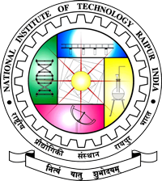
NATIONAL INSTITUTE OF TECHNOLOGY RAIPUR

Nomination Form for the Young Achiever Alumnus Award of NIT Raipur

- Full Name:

Date of Birth:

- Profession:

Present Position:

Address:
(a) Official |  | (b) Residential
Phone: |  | Phone:
Fax: | E-Mail:

- Degrees Obtained at NIT Raipur

Degree | Awards (e.g. PGM / Silver Medals etc.) | Department | Branch or Specialization | Year

- Professional Achievements

Period  From To | Position Held | Organization/Institution | Role | Remarks

- Record of Contributions to:

  - Intellectual Property (Publications/Design/Developments/Patents etc.)
  - Leadership (Entrepreneurship/ Organizational Development)
  - Society
  - Any other (Contribution towards NIT Raipur etc.)

- Peer Recognition (National/International Honours, Awards, Prizes including honorary degree)

- Membership/Fellowship of National/International Professional Bodies

- Specific outstanding Accomplishments meriting the award (within 100 words):
(Detailed biography may be provided as an annexure)

Name and Address of the Proposer | Name and Address of the Seconder
Signature of the Proposer | Signature of the Seconder

NOTE: Extra sheet can be attached as Annexure wherever necessary.

